

Harare Institute of Technology
Object-Oriented Programming
Lab 11 Mini-Project: Library Management System Project report

Names:
Chikodze Kingstone Tadiwanashe H250132W
Nyadzayo Abednico H250428H
Programme: Software Engineering
Submission Date: 15 October 2026

Aim
- Build a console Library Management System in Java allows the librarian to add books and DVDs, register members, lend and take back items, list overdue loans and search by title.

Objectives
- Build the classes Borrowable, LibraryItem, Book, Dvd, Member, Loan and Library in Java, with private fields, validation in the constructors and a toString, using inheritance, an abstract class and an interface, within the four hour lab session.
- Provide the six menu options required by the lab manual (add item, register member, borrow, return, list overdue, search by title) and handle bad input such as an unknown id, a duplicate id, an item already on loan and a fourth loan for one member, with a clear message each time and no crash.
- Save items, members and loans to three CSV files on exit and load them again on start, so nothing is lost between runs, and check this with the test data before the submission date of 15 October 2026.

Functional Requirements
These are the things the system must do. They come from the lab manual and the menu in Main.
- FR1: The system shall let the librarian add an item as a book (id, title, author) or a DVD (id, title, running time in minutes). It shall reject an empty field, a running time of 0 or less, and an id that already exists.
- FR2: The system shall let the librarian register a member with an id and a name. It shall reject an empty field and an id that already exists.
- FR3: The system shall let the librarian lend an item to a member. The item is then marked as on loan and a loan is recorded with the borrow date and the due date. It shall refuse the loan, with a clear message, if the item is already on loan or the member already has 3 loans.
- FR4: The system shall let the librarian take back an item by its id. The item becomes available again and the loan is removed from the member. An id that is not on loan gives an error message.
- FR5: The system shall list every loan that is overdue (today is after the due date), with the oldest due date first.
- FR6: The system shall search items by title. The search ignores upper and lower case, matches any part of the title and shows the results sorted by title (done with streams).
- FR7: The system shall list all items with their type, id, title, status and loan period (extra option added to check the state of the library).
- FR8: The system shall save all items, members and loans to CSV files when the user picks 0 and load them again the next time the program starts.
- FR9: The system shall allow a member to hold at most 3 loans at the same time.
- FR10: The system shall give a book a loan period of 14 days and a DVD a loan period of 7 days.

Non-functional requirements:
- All data must still be there after the program is closed and started again.
- The program shows a text menu and keeps running until the user picks 0.

Classes
Class | What it does
- Borrowable | Interface with borrow(Member) and giveBack().
- LibraryItem | Abstract parent with id, title and available. Implements Borrowable.
- Book | Extends LibraryItem, adds author. Loan period is 14 days.
- Dvd | Extends LibraryItem, adds running time in minutes. Loan period is 7 days.
- Member | id, name and the member's own list of loans. Enforces the limit of 3.
- Loan | Ties one item to one member with a borrow date. Works out the due date and says if it is overdue.
- Library | The core service. Holds the three maps and does borrow, return, overdue and search.
- FileStore | Saves and loads the data as CSV files.
- ItemNotAvailableException | Custom checked exception for an item that is already on loan.
- MemberLimitExceededException | Custom checked exception for a member who already has 3 loans.
- Main | The menu and user input.

Class Structure:
LibraryManagementSystem/
├── Borrowable.java
├── LibraryItem.java
├── Book.java
├── Dvd.java
├── Member.java
├── Loan.java
├── Library.java
├── FileStore.java
├── ItemNotAvailableException.java
├── MemberLimitExceededException.java
├── Main.java
└── data/
├── items.csv
├── members.csv
└── loans.csv

Data files:
- items.csv: type, id, title, extra, available. Example: BOOK,B1,Clean Code,Robert Martin,true
- members.csv: id, name. Example: M1,Tendai
- loans.csv: item id, member id, borrow date. Example: D1,M1,2026-10-14

How the project requirements are met:
- Encapsulation: every field is private. Constructors validate input (empty id, empty title, DVD time of 0 or less) so a bad object cannot exist.
  - Member.getLoans() returns an unmodifiable list so other classes cannot change it directly.
  - setAvailable, addLoan, removeLoan and restoreLoan are package-private, so only classes inside the system can use them.
- Inheritance: Book and Dvd extend LibraryItem and reuse its id, title and availability code.
- Abstraction: LibraryItem is abstract. loanPeriodDays(), getType() and getExtra() are abstract, so each subclass has to supply its own.
- Interface: Borrowable defines what can be lent and returned. LibraryItem implements it.
- Polymorphism: Loan calls item.loanPeriodDays() and never checks whether the item is a Book or a Dvd. Java picks 14 or 7 at run time.
  - FileStore also works through LibraryItem references and uses getType() and getExtra() to write each item.
- Custom exceptions: ItemNotAvailableException and MemberLimitExceededException are checked, so the compiler forces Main to deal with them.
  - Wrong input such as an unknown id, a duplicate id or an empty field throws IllegalArgumentException.
  - Main catches all of these and prints a message, so the program does not crash.
- Collections: items and members are stored in Map<String, ...> keyed by id. Loans are also a map, keyed by item id.
  - I used LinkedHashMap so items stay in the order they were added.
- Streams: searchByTitle uses filter, sorted and toList. listOverdue uses the same idea and sorts by due date.
- File persistence: FileStore writes with Files.newBufferedWriter inside try-with-resources and reads with Files.readAllLines. Data is saved on exit and loaded on start.

Class diagram
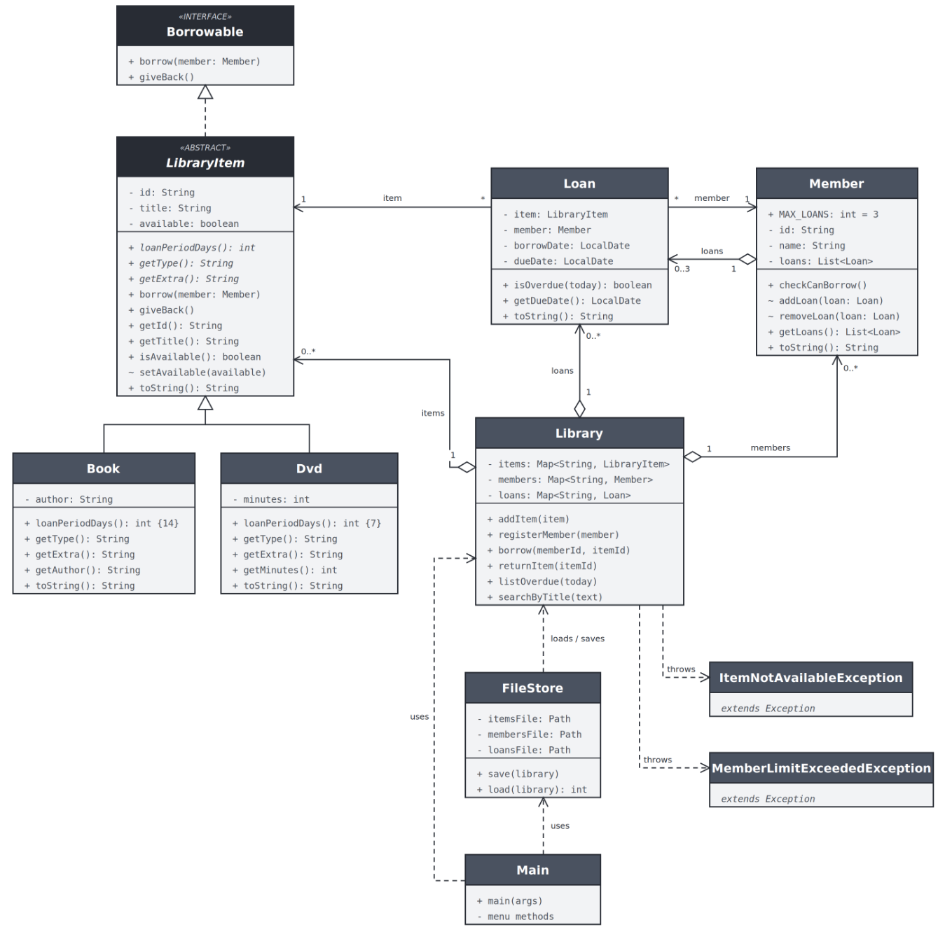

Test data
The data folder comes with a small set of test data, so the program has something to work with the first time it runs. It was chosen to cover every case the program has to handle.
items.csv (9 items)
Type | Id | Title | Author / minutes | Status
BOOK | B1 | Clean Code | Robert Martin | Available
BOOK | B2 | Java: The Complete Reference | Herbert Schildt | On loan
BOOK | B3 | Head First Java | Kathy Sierra | On loan
BOOK | B4 | Effective Java | Joshua Bloch | Available
BOOK | B5 | Introduction to Algorithms | Cormen, Leiserson, Rivest and Stein | On loan
DVD | D1 | The Social Network | 120 min | On loan
DVD | D2 | Hidden Figures | 127 min | On loan
DVD | D3 | The Imitation Game | 114 min | Available
DVD | D4 | Inception | 148 min | Available

members.csv (4 members)
Id | Name | Loans | Note
M1 | Tendai | 3 | At the limit of 3 loans, one of them overdue
M2 | Rudo | 1 | Has one overdue loan
M3 | Farai | 1 | Has one loan that is not overdue
M4 | Chipo | 0 | No loans, used for normal borrowing

loans.csv (5 loans, overdue column checked on 15 October 2026)
Item | Member | Borrowed | Due | Overdue
B2 Java: The Complete Reference | M1 Tendai | 2026-09-28 | 2026-10-12 | Yes
B3 Head First Java | M1 Tendai | 2026-10-05 | 2026-10-19 | No
D1 The Social Network | M1 Tendai | 2026-10-14 | 2026-10-21 | No
D2 Hidden Figures | M2 Rudo | 2026-10-02 | 2026-10-09 | Yes
B5 Introduction to Algorithms | M3 Farai | 2026-10-10 | 2026-10-24 | No

What the test data covers:
- M1 (Tendai) already has 3 loans, so borrowing a fourth item gives MemberLimitExceededException.
- B2, B3, B5, D1 and D2 are on loan, so borrowing any of them gives ItemNotAvailableException.
- B2 and D2 are overdue on 15 October 2026, so option 5 lists two loans, oldest due date first. Overdue is worked out from the date the program is run, so this changes as time passes.
- M4 (Chipo) has no loans, and B1, B4, D3 and D4 are available, so they can be used for a normal borrow and return.
- The author of B5 has commas in it, which tests the CSV quoting when the data is saved and loaded again.
- B2, B3 and B4 all have Java in the title, which tests the title search.

Output screenshots
Startup and exit
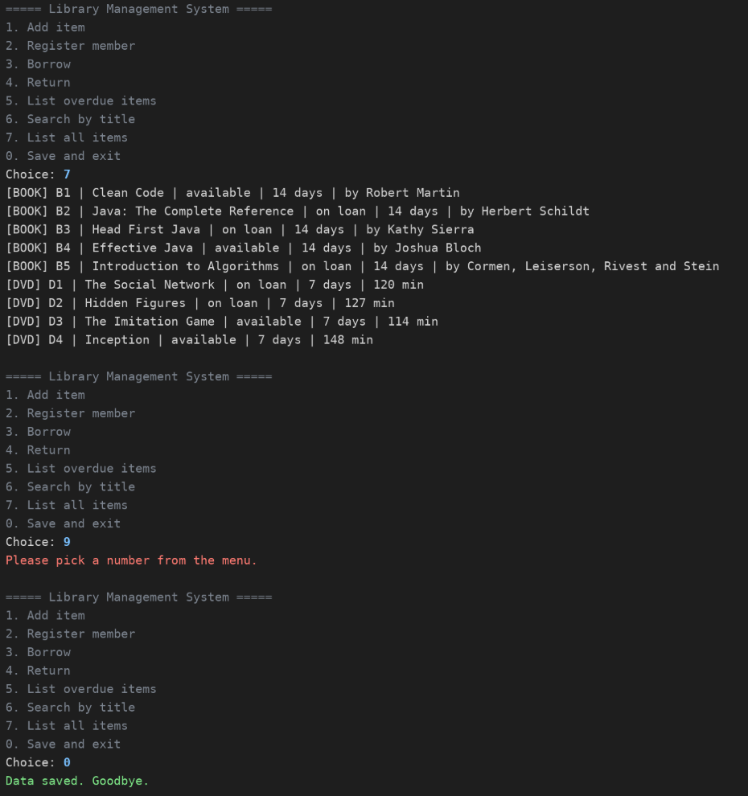

Add item and member
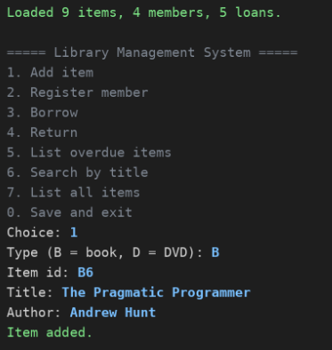

Borrow and return
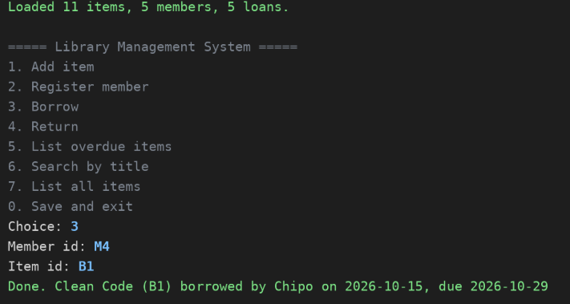

Borrow error
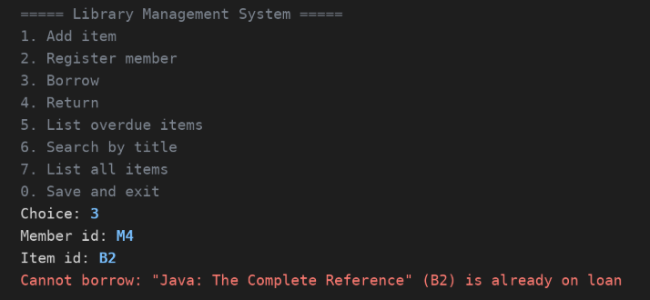

Input error
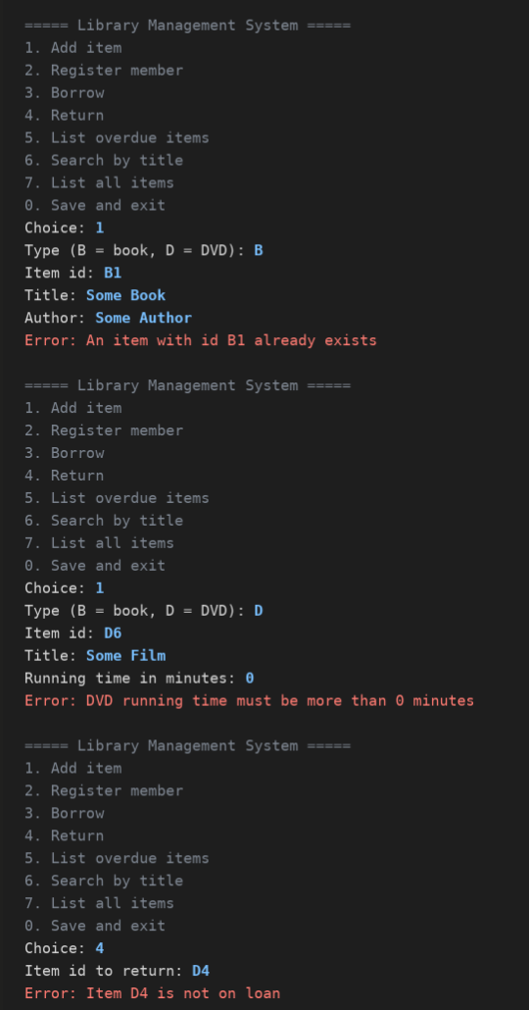

Conclusion
- The system meets every requirement in the lab manual and works across restarts.
- FileStore keeps all file work in one class, so swapping CSV for a database later would only touch that class.
- Putting the loan period in the subclasses meant Loan and Library needed no type checks at all.
- Writing the tests first for the edge cases (limit, double borrow, bad files) caught problems that normal menu use would not have shown.

